GRAND TRAVERSE BAND OF OTTAWA & CHIPPEWA INDIANS
Benodjenh Center Early Head Start, Head Start/GSRP and Child Care
Annual Report
June 1, 2019– May 31, 2020
Brief Background of GTB Head Start & Early Head Start
The Grand Traverse Band of Ottawa and Chippewa Indians (GTB) has been providing Head Start services for 28 years and Early Head Start services for 18 years. The program operates from September through July each year. There are 2 Head Start classrooms, a predominately 3-year old class with 17 enrolled children and a 4 year old room that is a blended classroom for the Great Start Readiness Program, (GSRP), which is a state funded grant and Head Start whose enrollment is 18 for a total of 35 Head Start slots.
The EHS program has 16 Center Base slots, 2 classrooms with 8 enrolled children each. GTB also has the EHS Home Base program. This program is funded for 32 pregnant women and children birth to 3 years of age. This program has not been fully enrolled for several years, a “Change of Scope” will be submitted to reduce that number from 32 to 20 pregnant women and children. With the change of scope, the program would eliminate one EHS Home Visitor position which has not be filled for several years, due to the lack of enrolled families. The program director and managers, along with discussion from Policy Council believe once approved, the number would be more manageable to reach. If the Change of Scope is approved, there will be major recruitment efforts to fill the available slots.
This school year that ended on July 30, 2020, the program was faced with many classroom challenges which were addressed as quickly as possible. The program added some new policies and procedures that addressed these issues.
The program also had staff vacancies throughout the year, which makes it difficult for any program to provide quality services. Employee requisitions are completed as quickly as possible when a vacancy occurs. Head Start and Early Head Start both have the Classroom/Bus Aid position open. These 2 positions are part time but are vital to the program, particularly in the event of absenteeism, if the programs are fully staffed and one person calls in for the day or is on vacation, there should always be two staff members available to teach the class. The interviewing process started for the 2 vacant Classroom/Bus the week of March 8, 2020, the week that we were closed down due to the pandemic. During the initial GTB Government shut down, there were no job postings at all, for obvious reasons. Even as the Government employees were able to return to work at 25% capacity, job vacancies were not posted.
March 12, 2020 was the last day of in person class time due to the COVID-19 pandemic. On Friday, March 13, 2020, in consultation with GTB Program Specialist and the GTB Tribal Manager, the decision was made to close temporarily. On Monday, October 16, 2020 the entire GTB Government was shut down, following the recommendations of CDC, State and Local Health Departments, and the GTB Tribal Council.
The Benodjenh Center was constructed and completed late in 2001 with three sources of funding, the Grand Traverse Band of Ottawa and Chippewa Indians, Head Start and HUD. The GTB Head Start/Early Head Start grant year is June 1 – May 31 of each year. Head Start/Early Head Start offers full year/full day programming with the school year operating from September through July of each year. Hours of operations were from 9:00a.m. – 3:00p.m., Monday through Thursday, with the children receiving nutritious breakfast, lunch and snack. The Benodjenh Center Child Care is available to families that are working or in school and need care before 9:00a.m. and after 3:00p.m. daily. Child Care is also available all day on Friday. The Benodjenh Center Child Care is open 7:30a.m.-5:30p.m. daily, Monday through Friday and cares for children between the ages of 3 – 12 years old. Child Care for infants/toddlers are for those enrolled in the EHS Center Based program only. Child Care is also offered every other Friday for the EHS Center Based families if needed.
GTB EARLY HEAD START STATISTICS 2019-2020
Funded Enrollment
Currently the program is funded for 48 Head Start children and pregnant women. The program provides Center Based services for 16 infants/toddlers and 32 Home Based families and pregnant women. Reaching full enrollment in the EHS Home Base program continues to be a challenge. The program is seeking to reduce the number from 32 to 24 families to be served. The funds that have been made available for a third EHS Home Visitor have been redirected to a full time EHS Center Base staff member. We are now serving the EHS Center Base families eight hours a day and it remains challenging when there is more than one staff member absent. The program has had to cancel classes when this happens due to being short staffed. We continue to advocate for adding another staff person and have confidence that this will alleviate this issue.
The Early Head Start Center Based program served 16 families throughout the year. The program had one child that turned 3 and transitioned into the Head Start classroom at the parent’s request, which has been a regular practice, particularly when the Head Start program isn’t at full enrollment. The vacancy for that position was filled quickly as there is a wait list for this program.

Families Served
**SOME INFO UNKNOWN OR MAY BE INACCURATE DUE TO COVID RELATED RESTRICTIONS
Families Served
The Early Head Start program served 38 families cumulatively including one pregnant woman. Of these families served, 34 were income eligible and 4 families were over income. These figures include both Center Base and Home Base. The average monthly attendance for Early Head Start Center Based was 11 students.
Early Head Start Services
- 100% had medical homes
- 90% were up to date on immunizations
- 90% were determined to have received all immunizations possible at the end of the enrollment year
- 0% had immunization exemptions
- 92% had medical insurance
- 78% up to date on EPSDT requirements (preventative & primary health care)
Dental
- 84% had dental homes
- % completed a professional dental exam-- UNKNOWN
- % received preventative care-- UNKNOWN

Disability
- 11% of enrolled 0-3-year-old children received services from Early-On
Nutrition
- 2,095 Breakfasts were served
- 2,133 Lunches were served
- 1,962 Snacks were served

Early Head Start Staff
- Benodjenh Center Supervisor (for all programs at the Benodjenh Center)
- Health/Disability Coordinator (shared position with HS)
- EHS Education & Family Services Coordinator
- Office Manager
- 2 EHS Teachers
- 2 EHS Assistant Teachers
- 2 EHS Classroom/Bus Aides (part time positions, one vacancy)
- 2 EHS Home Visitors
- Benodjenh Center Cook
- 1 Maintenance/Bus Driver
Early Head Start Staffing Changes & Staff Qualifications
Both lead EHS teachers have an AA in ECD as well as one of the EHS Assistant Teacher’s. The program has one EHS Assistant teacher currently enrolled in on-line classes through Bay Mills Community College, (BMCC). The four EHS classroom staff mentioned here are full time staff. The program also has two part time Classroom/Bus Aides that enrolled and completed CDA classes at Northwest Michigan College (NMC). They will have to complete the CDA process by being observed, interviewed and tested by the CDA Council.
Early Head Start Funding Sources for 2019-2020
Source Revenues
DHHS – Office of Head Start (OHS) $543,776.00
Required 20% Tribal Match $34,925.52
USDA $9,098.88
$587,800.40
Early Head Start Expenditures for 2019-2020
Wages $270,662.73
Fringe $98,757.95
Training & Technical Assistance $12,219.00
Administrative Costs $52,119.93
Other $139,837.17
Total Expenses $573,596.78

Early Head Start Projected funding for Year 2019-2020
Federal funding levels remained at the current level of 2018-2019 with the exception of the 2.5% COLA.
GTB HEAD START STATISTICS 2019-2020
Funded Enrollment 2019-2020
Currently the program is funded for 35 Head Start age children age 3-5. The Head Start program has two classrooms, one of which has 17 students that are predominately three-year-old. This is the maximum number of students that a 3-year classroom can have. The second classroom has an enrollment of 18 students that are predominately 4 years old. The program collaborates/partners with the Traverse Bay Intermediate School District, (TBA/ISD) with their Great Start Readiness Program, (GSRP). The children in the 4-year-old room receives both Head Start and GSRP services, a blended classroom. The focus of this room is to prepare children for kindergarten.
Families Served
**SOME INFO UNKNOWN OR MAY BE INACCURATE DUE TO COVID RELATED RESTRICTIONS
Families Served
The Head Start program served 39 families cumulatively. Of these families served, 29 were income eligible and 10 families were over income. The average monthly attendance for Head Start Center Based was 22 students.
Head Start Services
- 76% had medical homes
- 88% were up to date on immunizations
- 88% were determined to have received all immunizations possible at the end of the enrollment year
- 2% had immunization exemptions
- 74% had medical insurance
- % up to date on EPSDT requirements (preventative & primary health care)-- UNKNOWN
Dental
- 76% had dental homes
- % completed a professional dental exam-- UNKNOWN
- % received preventative care-- UNKNOWN

Disability
- 20% of enrolled 3-5-year-old children received IEP’s
Nutrition
- 2,907 Breakfasts were served
- 3,007 Lunches were served
- 2,615 Snacks were served
Head Start Staff
- Benodjenh Center Supervisor
- Health/Disability Coordinator
- HS Education & Family Services Coordinator
- EHS Education & Family Services Coordinator
- Office Manager
- 2 HS Teachers
- 2 HS Assistant Teachers
- 2 HS Classroom/Bus Aides (part time positions)
- Benodjenh Center Cook
- 1 Bus Driver (part time position)
Staffing Changes & Staff Qualifications
There have been challenges in the last couple of years with the HS/GSRP Teacher position, however In July 2019, a qualified candidate with proper Early Childhood credentialing applied, interviewed, and was offered position. The candidate accepted and was hired. The Head Start program meets the national requirements for teacher certification, as 50% of teaching staff has a Bachelor’s Degree in Early Childhood Education. The newly hired Head Start/GSRP Teacher possesses an Elementary State of Michigan Teaching Certificate with an Early Childhood and Social Studies Endorsement. In addition, the Head Start Education & Family Services Coordinator possesses a State of Michigan Elementary Teaching Certificate with an Early Childhood Endorsement as well as a Master’s Degree in Early Childhood Education. The Assistant Teacher in this classroom is currently working on completing the CDA process with approximate completion expected by the end of the 2020-2021 school year.
The teacher in the second Head Start classroom is currently working on her Bachelor’s Degree in Early Child Education through Ferris State University with completion expected in 2021. The Assistant teacher in this classroom is currently working on her combined CDA-Associate’s Degree with approximate completion expected in 2023.
Head Start Funding Sources for 2019-2020
Source Revenues Source
DHHS – Office of Head Start (OHS) $293,649.21
Required 20% Tribal Match $18,969.49
USDA $20,252.35
GSRP (State funding) $56,814.00
Total Revenue $463,540.84
Head Start Expenditures for 2019-2021
Wages $175,560.23
Fringe $ 60,539.14
Training & Technical Assistance $ 4,339.33
Administrative Costs $ 62,531.74
Other $96,771.68
GSRP (State funding) $ 56,814.00
Total Expenses $456,556.12

Head Start Projected funding for Year 2020-2021
Federal funding levels are expected to maintain at current levels. The program has a partnership with Traverse Bay Area Intermediate School District (TBAISD) and receives funding for classroom staff to operate one Blended Head Start/Great Start Readiness Program (GSRP) classroom. This classroom will serve 17-18 four-year children preparing them for their next educational steps. GSRP is a per child allocation awarded to the local district based on a formula determined by the Michigan Legislature. The funds received from this partnership will continue to allow the program to add additional federal funds to other areas of the Head Start budget.
Audit Report
Below are excerpts from the 2019 GTB Audit which includes the Independent Auditor’s Report followed by the findings:
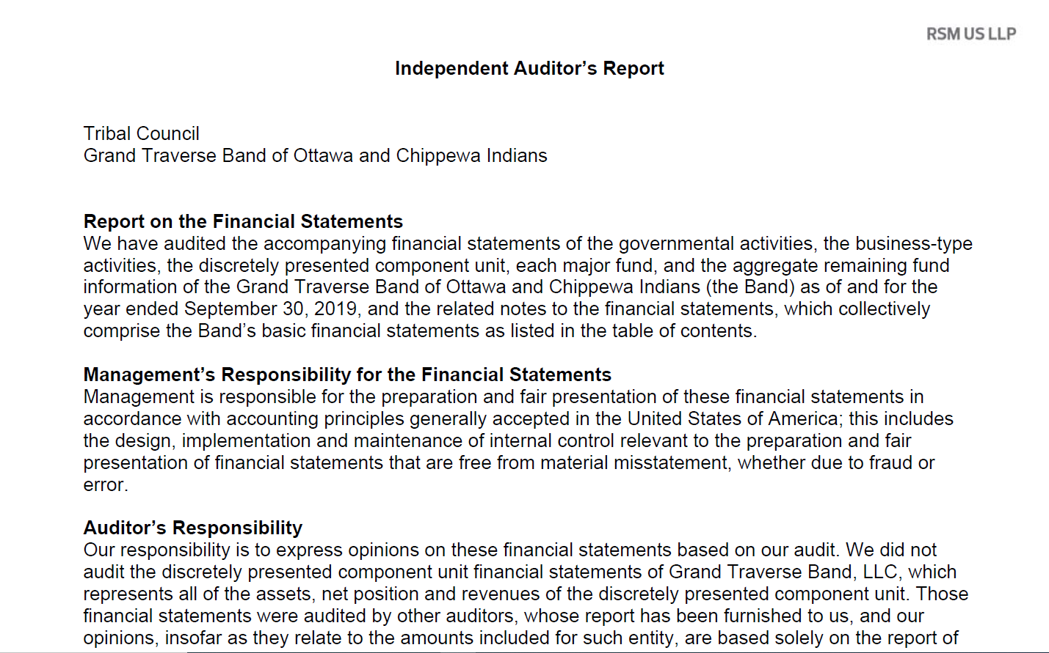
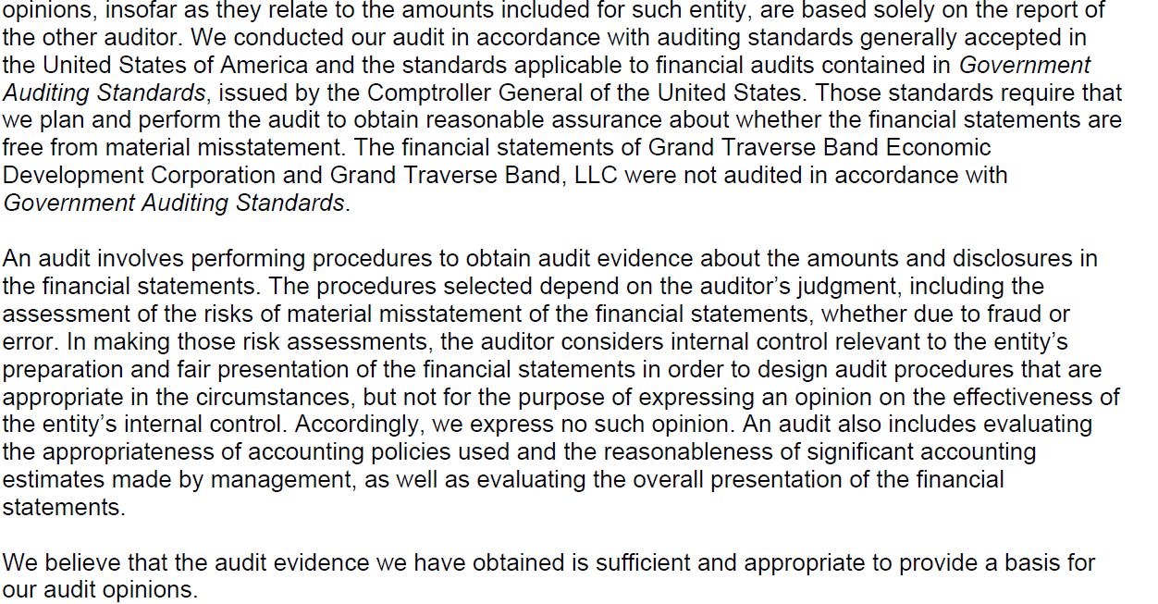
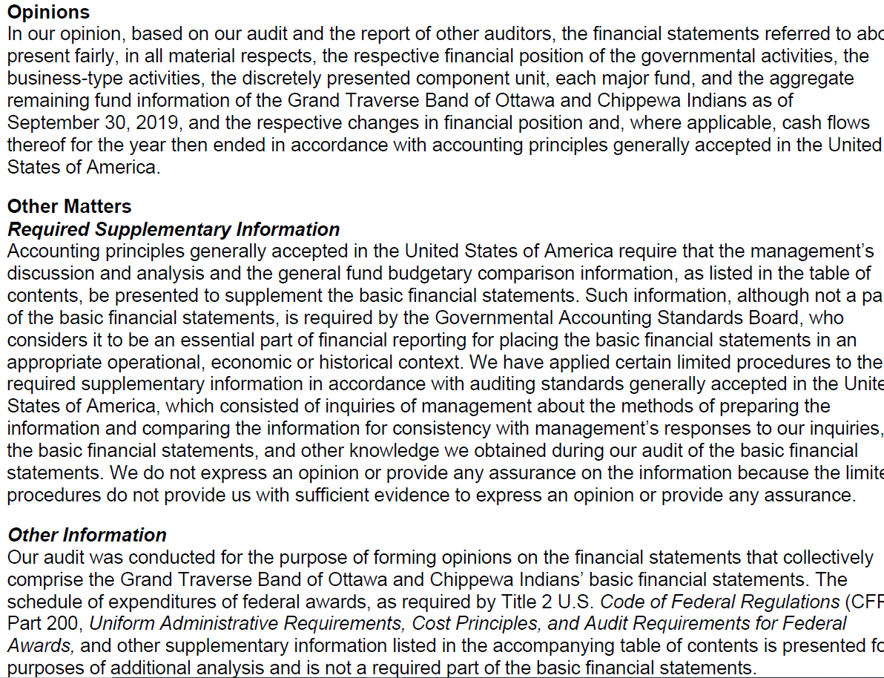
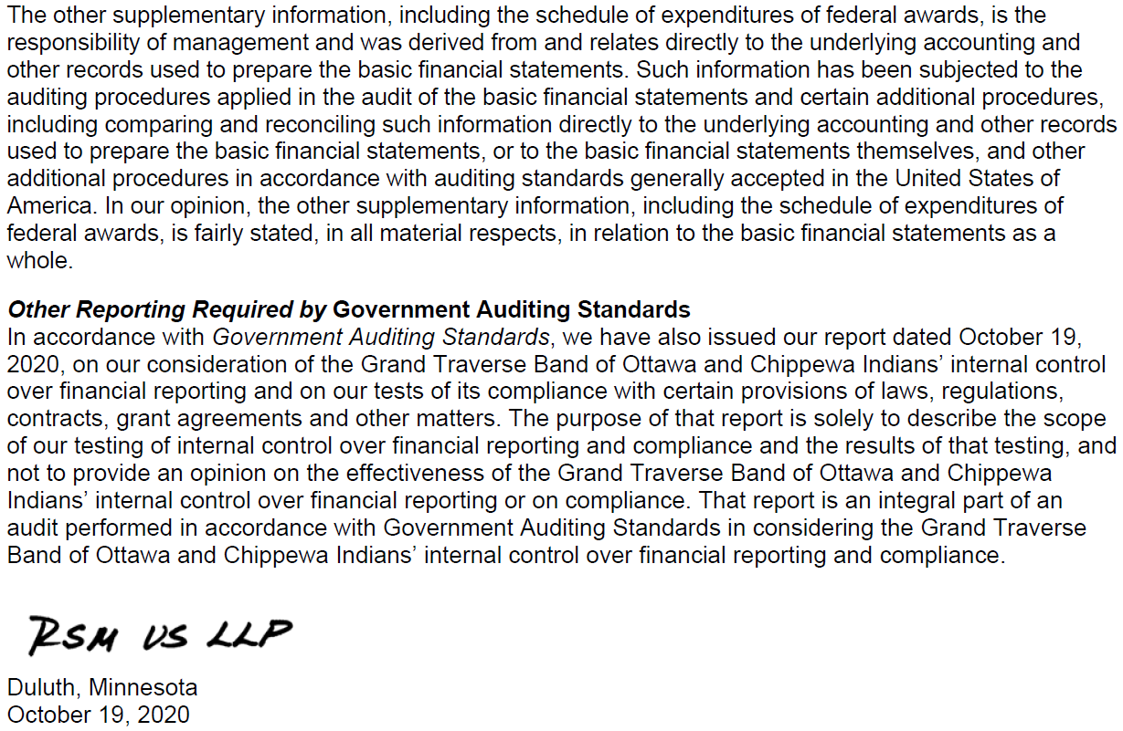
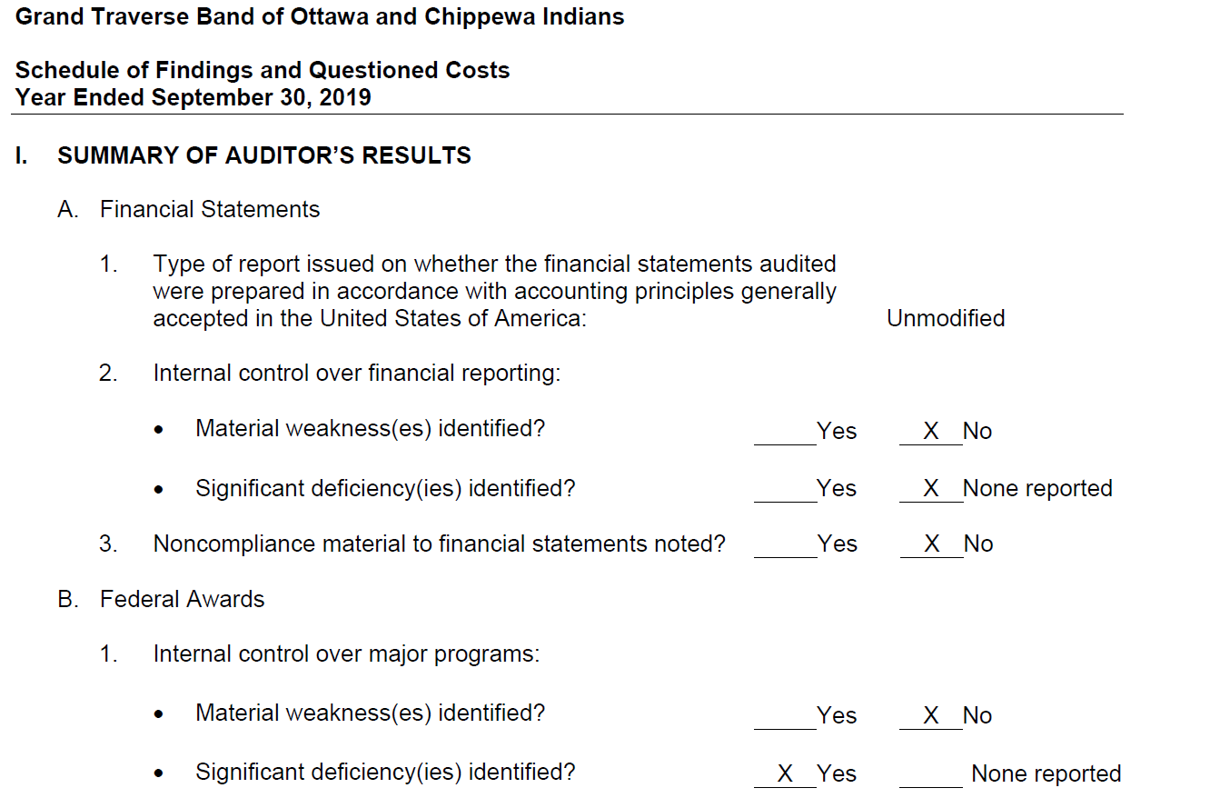
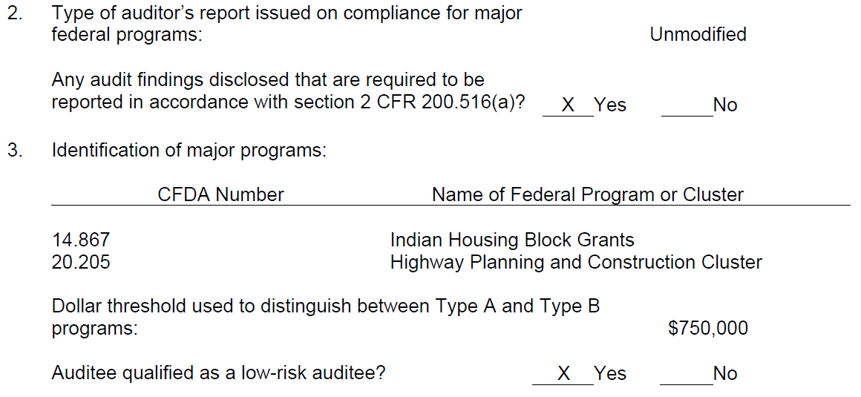
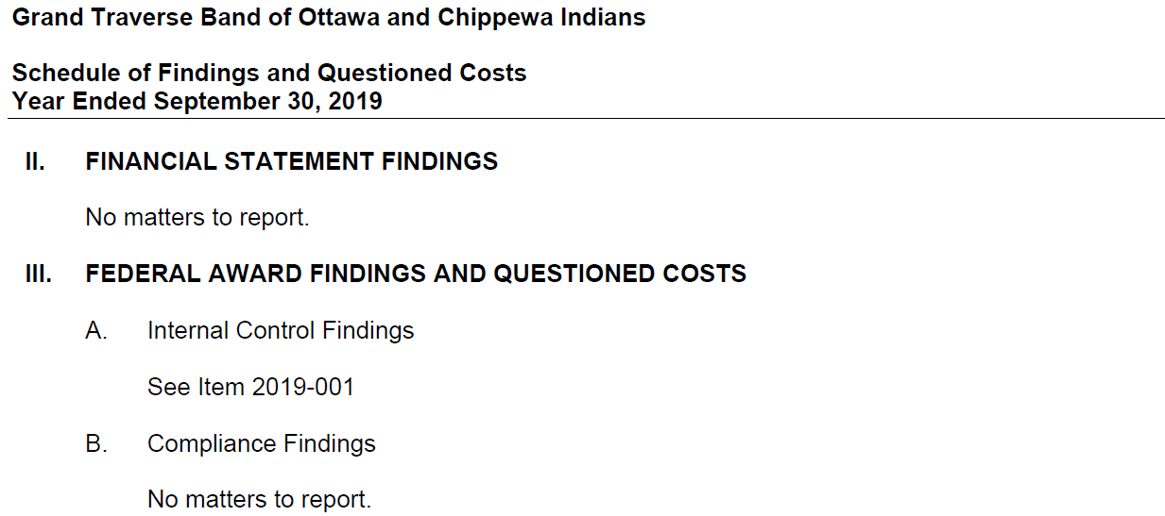
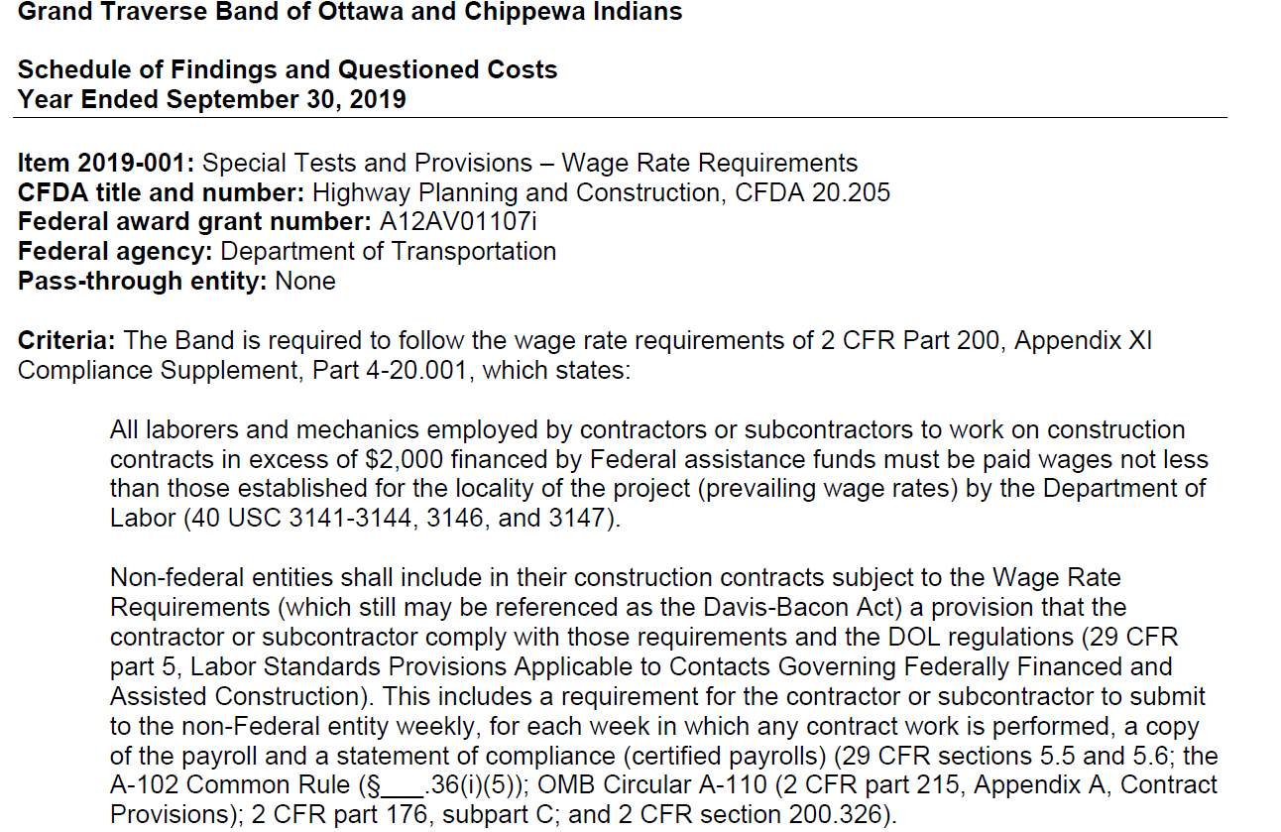
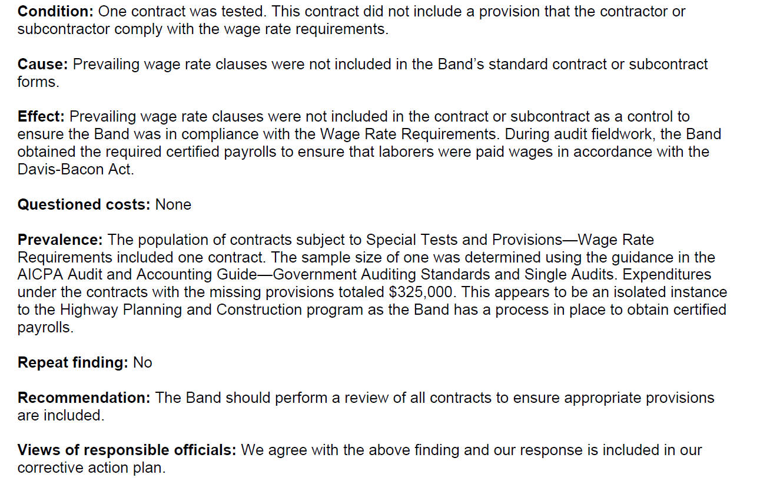

HEAD START & EARLY HEAD START INFORMATION 2019-2020
FEDERAL MONITORING
The program had 4 Federal monitoring reviews in our last 5-year grant cycle. The first was Environmental Health and Safety (2016), the second was Comprehensive Health and Safety/Focus Area 2 (2017), the third was a CLASS review (2017), and the last was a safety review (2019).
CURRICULUM
The GTB Head Start and Early Head Start programs utilize The Creative Curriculum for all children enrolled in the center based programs. The Creative Curriculum is a comprehensive, developmentally appropriate, research-based resource that aids our teachers to be effective and intentional while supporting active learning and promoting children’s progress in all developmental areas.
The Benodjenh Center’s EHS Home Based Program uses the Parents as Teachers Curriculum. It is used to help Home Visitor’s accomplish goals as well as being able to support and respond to individual family needs.
The Parents as Teachers Evidence-Based Home Visiting Model is a home visiting, parent education model. The model provides services to families with children from prenatal through Kindergarten.
The seven principles for providing Home Based family services include:
- Individualizing services
- Responding to the family as a system
- Establishing a collaborative relationship between the Home Visitor and the family
- Remaining flexible
- Promoting coping and problem-solving skills
- Facilitating learning of new skills and knowledge to future situations
- Assessing progress and modifying services as needed.
SCHOOL READINESS Policies/Procedures & GOALS
Each year, the GTB EHS/HS/GSRP programs develop school readiness goals in cooperation with parents to ensure that students achieve their maximum potential. The Benodjenh Center HS/HS/GSRP Programs use the five domains established by the Office of Head Start (ELOF) to create our own School Readiness Goals. The Creative Curriculum along with Teaching Strategies GOLD are used as a basis to plan and implement developmentally appropriate practices for students. Initially (at the first Parent/Teacher Conference), the Ages and Stages Questionnaires (ASQ-3) are used with parents to assess/screen children and set up individual goals.
The classroom staff (Lead Teacher/Assistant Teacher/Classroom/Bus Aide) are responsible for planning and implementing lessons (weekly), individualizing for every child (daily), writing/entering individual child observations (daily), and finalizing assessment checkpoints (December, March, and July). Teachers also share individual child progress with parents (at each parent/family contact) using the Teaching Strategies Program.
The EHS/HS/GSRP Education & Family Services Coordinators are responsible for monitoring lesson plans, conducting classroom observations, and aggregating/analyzing data in the Teaching Strategies GOLD Program. This data is used as a basis for providing staff with professional development opportunities. Additionally, this information allows for intentional planning and individualizing by teachers for every child.
The EHS/HS/GSRP Education & Family Services Coordinators are responsible for reporting the progress of the children in our program towards achieving School Readiness Goals. Parents are informed about School Readiness several times throughout the year. First, they receive a detailed explanation at our Parent Orientation in August. Second, they are reviewed at monthly parent meetings. Third, they are reported in the Benodjenh Center’s monthly newsletter as well as the Grand Traverse Band’s Tribal monthly newspaper. Additionally, they are reviewed at our monthly Policy Council meetings. Classroom staff re-visit our School Readiness Goals with parents before school starts at the first Parent/Teacher Conference and at each formal contact with parents. Teachers give a letter to parents explaining our specific goals and they are asked to give their input about what they think is important in supporting their child to be ready for school.
Cognition/Approaches to Learning, Mathematics, Scientific Reasoning
SR Goal- Children will gain knowledge by using all of their senses to learn and explore through observing, manipulating, and asking questions while using cognitive skills, math & number concepts, and scientific reasoning.
Objective 1
EHS
Children will remember the sequence of daily routines.
Action Steps: Teachers will use TS GOLD Objective 12, a-b
12. Remembers and connects experiences.
a. Recognizes and recalls
b. Makes connections
Example: Demonstrates and explains how different experiences relate, i.e., your sweater goes over your head just as tout t-shirt goes over your head.
Objective 2
Children will remember and connect experiences through consistency and repetition by observing, manipulating, and exploring their environment.
Action Step: Teachers will use ELOF Goal IT-C 3. Child recognizes differences between familiar and unfamiliar people, objects, actions, or events.
HS/GSRP
Objective 1
Children will remember the sequence of daily routines and recall familiar people, places, and objects.
Action Steps: Teachers will use TS GOLD Objective 12 a-b & 13
12. Remembers and connects experiences
a. recognizes and recalls
b. Makes connections
13. Uses classification skills
Examples: See example above for Objective 12. Objective 13: Play sorting and matching games using materials that are familiar to the child. Think about the child’s family background, neighborhood, and community as you choose familiar materials, e.g., toys, clothing, utensils, food labels, etc.
Action Step: Teachers will use ELOF Goal IT-C 10. Child uses matching and sorting of objects or people to understand similar and different characteristics.
SR Goal- Children will show curiosity, interest, and eagerness while using all of their senses to explore their environment and discover what objects and people do, how things work, and how they can make them happen.
SR Goal- Children will show an increased use of creativity, imagination, and the ability to solve problems during play and other routine tasks.
Objective 1
EHS & HS/GSRP
The children will be given developmentally appropriate tools to safely explore, use their imagination, encourage curiosity and eagerness to learn within their environment throughout the day.
Action Steps: Teachers will use TS GOLD 11 a-e
11. Demonstrates positive approaches to learning
a. Attends and engages
b. Persists
c. Solves problems
d. Shows curiosity and motivation
e. Shows flexibility and inventiveness in thinking
Examples: Provide one or two toys or materials at a time for young infants, exchanging them when the child’s attention diminishes. Provide appropriate amounts of visual stimuli, e.g., pictures, mobiles, and signs, so children are neither over nor under stimulated. Provide children with time, space, and a variety of interesting materials for play. Rotate materials regularly to maintain children’s interest. Provide materials that build on those already familiar to the children.
Action Steps: The teachers will use ELOF Goal IT-C 1 Child actively explores people and objects to understand self, others, and objects. ELOF Goal IT-C 6 Child uses a variety of strategies in solving problems. ELOF Goal IT-C 7 Child uses reasoning and planning ahead to solve problems. ELOF Goal IT-C 9 Child uses special awareness to understand objects and their movement in space. ELOF Goal IT-C 13 Child uses pretend play to increase understanding of culture, environment, and experiences.
Social and Emotional Development
SR Goal- Children will demonstrate the ability to regulate their own emotions and behaviors.
Objective 1
EHS
Children will progress in managing separations without distress.
Action Step: Teachers will use TS GOLD Objective 1 a-c.
1. Regulates own emotions and behaviors
a. Manages feelings
b. Follows limits and expectations
c. Takes care of own needs appropriately
Examples: Establish and practice consistent routines. Give children alternative ways to express their feelings, tell the child, “if you feel angry, tell us. Say, I’m angry! That way we can help you.” or model taking deep breaths or doing relaxation exercises and tell the child what you are doing and why. Ask families about self-care activities in which the child participates at home and set up those opportunities at school. Describe what you are doing during caregiving routines so children can learn the sequence of actions to care for themselves.
Action Steps: Teachers will use ELOF Goal IT-SE 6 Child learns to express a range of emotions. ELOF Goal IT-SE 12 Child shows confidence in own abilities through relationships with others. Goal
Objective 1
HS/GSRP
Children will form positive relationships with adults and peers.
Action Step: Teachers will use TS GOLD Objective 2 a-d
2. Establishes and sustains positive relationships
a. Forms relationships with adults
b. Responds to emotional cues
c. Interacts with peers
d. Makes friends
Examples: Establish and practice consistent routines. Interact one-on-one with children daily, playing and talking with them. Respond promptly and consistently to children’s needs. Acknowledge children’s positive interactions. Discuss and read books about friendships.
Action Steps: Teachers will use ELOF Goal P-SE 1 Child engages in and maintains positive relationships and interactions with adults. ELOF Goal P-SE 3 Child engages in and maintains positive interactions and relationships with other children. ELOF Goal P-SE 4 Child engages in cooperative play with other children. ELOF Goal P-SE 7 Child expresses care and concern toward others.
Objective 2
Children will progress towards joining peer groups and using materials together appropriately.
Action Step: Teachers will use TS GOLD Objective 3 a-b
3. participates cooperatively and constructively in group situations
a. Balances needs and rights of self and others
b. Solves social problems
Examples: Explain conflicts to children when they take place, describing people’s feelings and the reasons for those feelings. Coach children to use assertive (not aggressive) language, e.g., say “Billy, you tell him, it’s my turn now.”
Action Steps: Teachers will use ELOF Goal P-SE 5 Child uses basic problem-solving skills to resolve conflicts with other children. ELOF Goal P-SE 7 Child expresses care and concern towards others
Perceptual, Motor, and Physical Development
SR Goal- The children will be able to strengthen and demonstrate their fine and gross motor skills to the best of their ability.
Objective 1
EHS & HS/GSRP
The children will be supported daily and given the opportunity to observe and demonstrate gross and fine motor skills using various tools and movement experiences.
Action Steps: Teachers will use TS GOLD Objectives 4, 5, 6, 7 a-b
4. Demonstrates traveling skills
5. Demonstrates balancing skills
6. Demonstrates gross-motor manipulative Skills
7. Demonstrates fine-motor strength and Coordination
a. Uses fingers and hands
b. Uses writing and drawing tools
Examples: Provide a wide variety of fine-motor activities that interest and appeal to all children in the program. Include items that are easy to manipulate by hand and add more challenging activities as quickly as possible without causing frustration. Provide balls of various sizes, textures, and grips to explore. Include balls with chimes, bells, and visible items rolling inside. Provide sufficient equipment for each child to participate. Include a variety of shapes, sizes, textures, and weights to encourage experimentation and active participation.
Action Steps: Teachers will use GOAL IT-PMP 3 Child demonstrates effective and efficient use of large muscles for movement and position. GOAL IT-PMP 7 Child uses hands for exploration, play, and daily routines. Goal IT-PMP 8 Child adjusts reach and grasp to use tools. GOAL P-PMP 1 Child demonstrates control, strength, and coordination of large muscles. GOAL P-PMP 3 Child demonstrates increasing control, strength, and coordination of small muscles.
Language, Communication, and Literacy
SR Goal- Children will be able to communicate their thoughts, wants, and needs by speaking through the use of sign language, and/or by gesturing throughout the day.
Objective 1
EHS & HS/GSRP
Teachers will use repetitive and consistent communication (sign language, verbal, gestures, visuals, and written words) to help children develop the ability to follow simple requests.
Objective 2
EHS & HS/GSRP
The children will comprehend and respond to text, sign language, and visual cues as meaningful and organized systems of communication.
Action Steps: Teachers will use TS GOLD Objective 8 a-b, 9 a-d, 10 a-b
8. Listens to and understands increasingly complex Language
a. Comprehends Language
b. Follows directions
9. Uses language to express thoughts and needs
a. Uses an expanding and expressive vocabulary
b. Speaks clearly
c. Uses conventional grammar
d. Tells about another time and place
10. Uses appropriate conversational and other communication skills
a. Engages in conversations
b. Uses social rules of language
Examples: Use singsong speech and exaggerated facial expressions to encourage babies to listen and focus on what is said. Talk often to children, using rich language to describe objects, events, and people in the environment. Use language that is easy for the child to understand, explaining new vocabulary as you use it. Serve as a good speech model for children. Speak slowly and model correct grammar. Encourage children to use explanatory talk explaining and describing by modeling it. Provide props that encourage talking, e.g., telephones and puppets. Build on the child’s language. Rephrase what the child says and then add more. Use the same communication system as the child, e.g., point to pictures on his/her picture board to ask if she wants to go outside.
Action Steps: Teachers will use ELOF Goal IT-LC 1 Child attends to, understands, and responds to communication and language from others. ELOF Goal IT-LC 3 Communicates needs and wants non-verbally and by using language. ELOF Goal IT-LC 5 Child uses increasingly complex language in conversations with others. ELOF Goal IT-LC 7 Child understands an increasing number of words used in communication with others. ELOF Goal IT-LC 11 Child recognizes pictures and some symbols, signs, or words. ELOF Goal P-LC 2 Child understands and responds to increasingly complex communication and language from others. ELOF Goal P-LC 4 Child understands, follows, and uses appropriate social and conversational rules. ELOF Goal P-LC 5 Child expresses self in increasingly long, detailed, and sophisticated ways. ELOF Goal P-LC 6 Child understands and uses a wide variety of words for a variety of purposes.
SERVICES PROVIDED
Early Head Start/Head Start/GSRP programs are required to provide comprehensive early childhood education services to children from birth through 5 years of age, focusing on the individual learning styles of children while incorporating creative arts, literacy, language development, math, science, physical health & development, and social/emotional development. Examples may include:
- Nutritious meals
- Transportation
- Health Screenings which include developmental, social/emotional development, height, weight, vision, and hearing
- Anishanaabemowin classes
- Field trips
- Speech, OT and/or PT services for eligible students on-site
- Early-On services for eligible infants/toddlers
- Parent/teacher conferences & Home Visits
FAMILY INVOLVEMENT ACTIVITIES INCLUDING PARENT TRAININGS
- Monthly Family Dinners/Parent Meetings/Hands–On Experiences (monthly)
- Parent Committee (monthly)
- Policy Council (monthly)
- EHS Home Based Socializations (3 times per month)
- Family Partnerships/Goal Setting
- Distribute Flyers for Local Early Childhood Dev. Events
- Parent Trainings (Conscious Discipline, Cooking/Eating on a Budget/Choosemyplate.gov, What, Why, & How of the Devereaux Early Childhood Assessment, Managing Stress, Fire & Health Safety, Building Self-esteem in Young Children, Developmentally Appropriate Reading & Literacy Activities/Book Give-A-ways, Resiliency in Children, Family Engagement & School Readiness, Month of the Young Child Activities, The Importance of Play, and the Importance of Parent Involvement, )
- Opportunities to Participate/Volunteer in the Classrooms
- Parent/Teacher Conferences & Home Visits (a total of 4 per year)
- Field Trips
- Parent Input with School Readiness Goals
- Lending Toy Library
- School to Home Activities Offered

Policy Council and Governing Body (Tribal Council) Membership
The GTB Early Head Start/Head Start/GSRP programs have an active Policy Council that works in conjunction with the GTB Tribal Council to insure a high-quality early childhood program for all enrolled children/families. Below is the list of members for each perspective group:

TRIBAL COUNCIL
Tribal Council Chairman – David Arroyo
Tribal Council Vice-Chair – Mark Wilson
Tribal Council Secretary – Theresa Pelcher
Tribal Council Treasurer – Donna Swallows
Tribal Councilor – Tina Frankenberger
Tribal Councilor – Robert Kewaygoshkum
Tribal Councilor – Brian Napont

Policy Council
Chairperson – Parent Representative – Theresa Pelcher
Vice-Chair – Vacant
Recording Officer – Parent Representative – Elsa Bustos
Policy Council Member – Elder Representative – Deb Fox
Policy Council Member – Community Representative – Helen Cook
Policy Council Member – Community Representative – Sean Cahill
Policy Council Member – Parent Representative – vacant
Tribal Council Liaison – Tribal Councilor Kim Vargo

GTB Head Start & Early Head Start Information Disclosure
The 2019-2020 GTB Early Head Start/Head Start/GSRP annual report will be made available for public viewing and can be accessed through the following links: http://www.gtbindians.org/benodjenh.asp
https://benodjenhcenter.weebly.com/
https://www.facebook.com/GTBBenodjenh/

This report will also be distributed to all GTB Satellite offices and available upon request.

Submitted by:
Trista Erickson
Head Start Education &
Family Services Coordinator/
Interim Director

